**ProbStats Problem Solving Steps, by Problem Type**

**Chapter 2**

Probability = $\frac{\# of ways to succeed}{\# of total ways}$

P(anything) – **List out the whole sample space of outcomes**

**List out any events**, simple or compound, of outcomes in question.

**Draw a Venn** if one can be drawn.

Label A, B, A’, B’, unions and intersections with all givens.

Think carefully about what combinations equal each other.

(You’re just looking for the same flat coverage, not rule)

**Convert P(success) into complements(-), unions(+), intersections(x).**

Think carefully about what’s being asked, what’s provided.

**You should now have equations that came out of the words.**

**Use: Equalities of Venn components to fit to your equations.**

**1-P(A’), Union rules to work into quantities needed.**



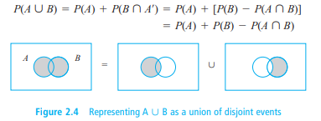

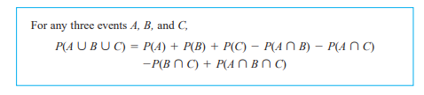

**Draw the WHOLE tree if one can be drawn.** Label with all givens.

Check for equally likely outcomes: $\frac{\# of outcomes in an event A}{\# of outcomes in the sample space}$

This also happens when you can split the event in half, etc

**SIMPLE PROBABILITIES can be calculated as soon as you have these counted ok**

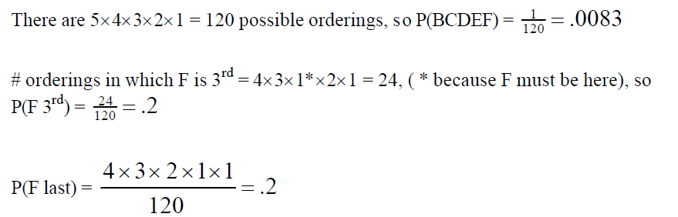

**IT DEPENDS ON THE DEFINITION OF THE INDIVIDUAL “OUTCOME”, WHAT’S INCLUDED, YOU MAY NEED TO:**

**Split into desired sub-event(s) + remaining pieces or sub-events = # ways success**

Same as above, you are fixing the *ways* to succeed, and letting the rest of it vary.

**And its just the product of sub-events, in N(A), over N.**

Here N is the total ways of getting *any* outcome.

**When it wants the P(*i*th) in a series:**

**Fix that way as 1 way when totals must be counted.**

Careful it is included when in a series calculation

**Leave it out of calculations when it’s fixed others vary**

**And that’s how the ways of success are specified**

Think about # ways of success. Be simple or use $\left(\begin{aligned}n \\ k\end{aligned}\right)P_{k,n}$

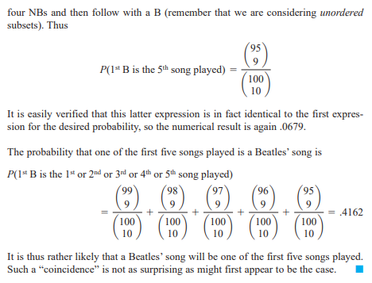

**Build out your P(compound) with unions, intersections etc of simples obtained**

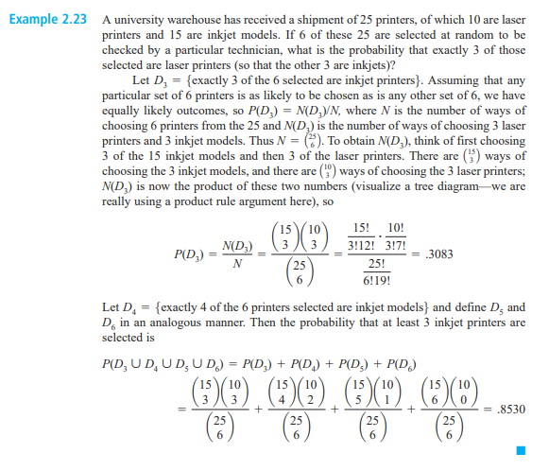

THINK about when the question is asking for a compound…start with simples.

**WATCH for the point you have calculated the complement, all but last one, etc.**

**Use 1-P(A’) as soon as you get there.**

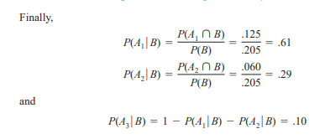

**IF YOU CAN’T HAVE DATA FOR p(x) LOOK FOR A WAY TO USE COMPLEMENTS**

**(1- INTERSECTIONS OF COMPLEMENTS) = p(x)**

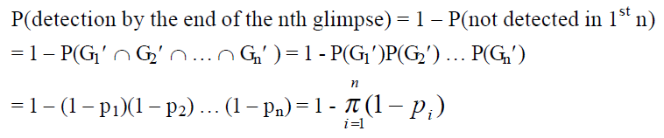

**THE COMPLEMENT OF “ALL” IS “AT LEAST ONE” AND VICE-VERSA. AT MOST**

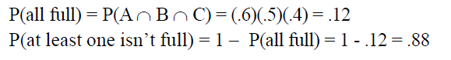

Ordered pairs can be selected n1 x n2 ways. The product of their # of ways each.

This just expands as you add branches …x n3 x n4… etc.





**CONDITIONALS – figure out what is given what, what is being asked, then set up the rule and strategize backwards. You won’t need a tree if there is one branch.**

**Write givens as P(A),P(B) unions, intersections, complements then work forward after you have made an equation between these and what is desired**

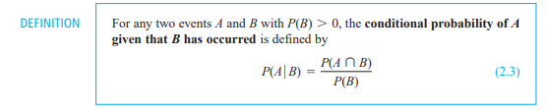

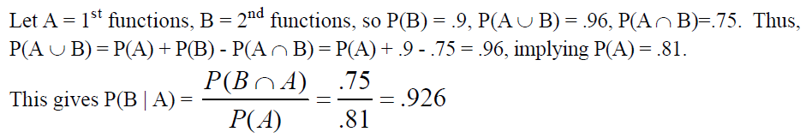

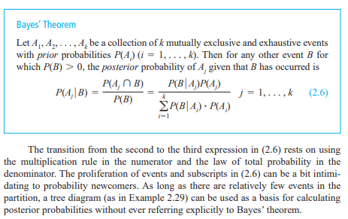

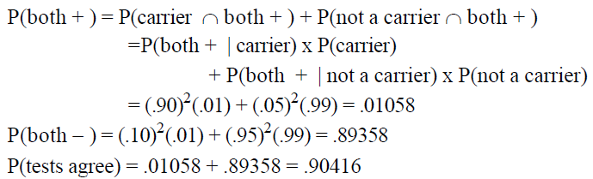

**You may need to use Total Probability to get the denominator**

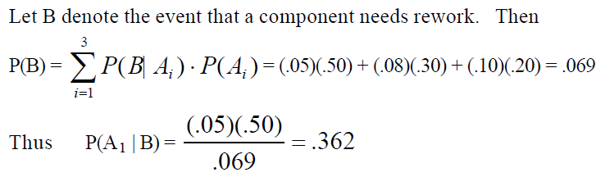

**COMBINING simple probabilities and conditionals may occur if the sample space is decided that way:**

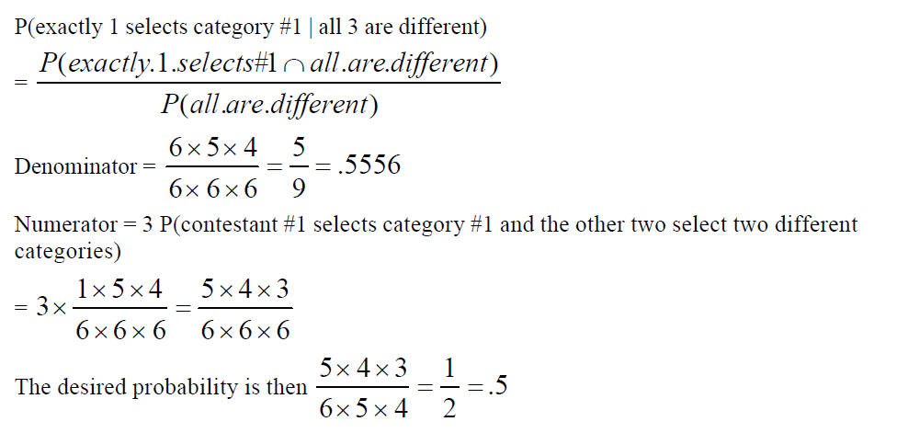

**If anything is INDEPENDENT…start writing out conditionals immediately.**

**Start with the obvious one and then list the other three A’, B’, etc too**

THEN WRITE OUT THESE RULES AND LOOK FOR A CHANCE TO USE THEM

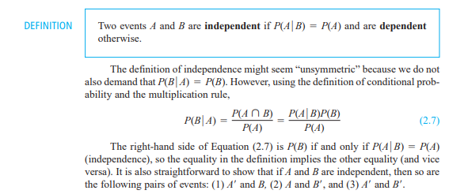



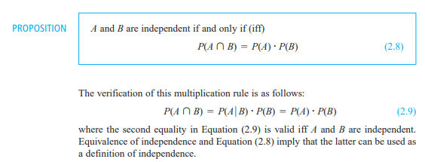

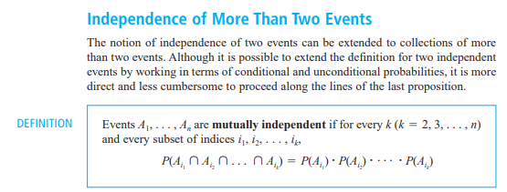

So now you are getting Venn, into equations, applying addition rule, then independence. Get P(A), P(B)’s onto one side and numbers on the other.

Convert to x and y and plug your equations into each other when you can sub

Solve. Ex: Use quadratic formula. **EVERY GIVEN IS USED EVENTUALLY!**

**Chapter 3**

**COMPUTING A PMF is two parts: 1) Figure out what X is and the range of values**

**2) Computing a p(x), as above, for each value**

**COMPUTING A MEAN – $\sum{x ∙p(x)}$- summing across their respective products**

For functions you plug that in instead of x:

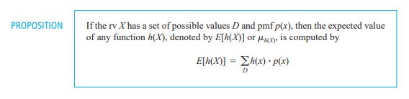

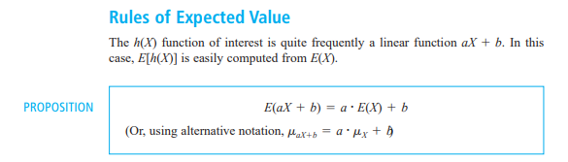

**COMPUTING A VARIANCE is next, - $\sum_{x=min}^{max}{{\left(x-μ\right)}^{2}p(x)}$- summing each**

**Or** 

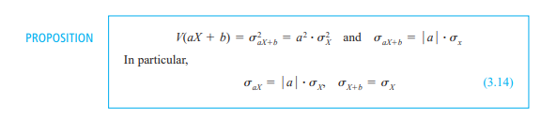

**COMPUTING STD DEV, now you take $\sqrt{σ}$**

**IF THERE IS EVER A HINT, CALCULATE AND USE THAT STARTING POINT**

**Bernoulli RV is when x can only take on 0 or 1. Simplest PMF**

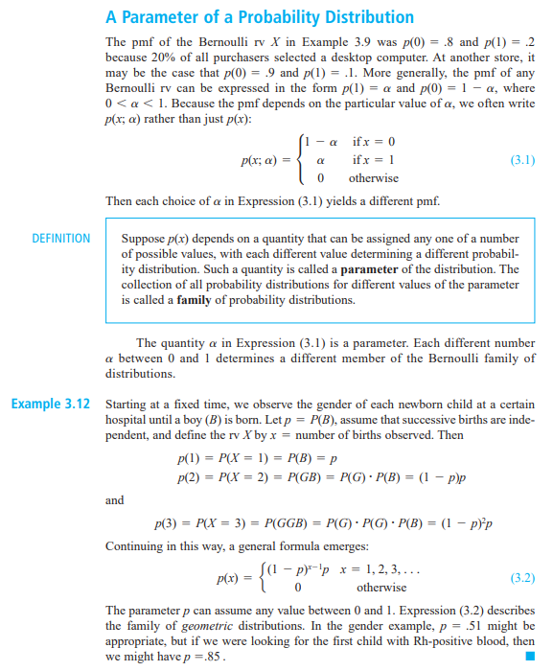

**PARAMETER – is a number that p(x) depends on inside the PMF. Above it is $α$.**

**IT CAN BE TOUGH TO SPOT PARAMETERS IF THEY ARE IMPLIED**

**LOOK FOR A RELATIONSHIP BETWEEN P(A) AND P(B) THAT MUST BE**

**if it throws out a lower case letter that’s it, USE IT, model the relationship**



**Don’t confuse n and X just because you are counting events**

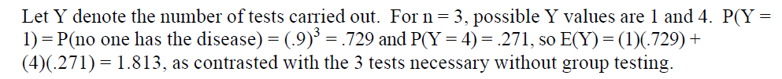

Here only one test means all three negative. Multiplied. Positive>1, complements

Having both scenarios, their X and p(x) – expected value is calculated.

**CDFs are summing the PMF up to some point. Or, taking “1 –“ to get the top.**

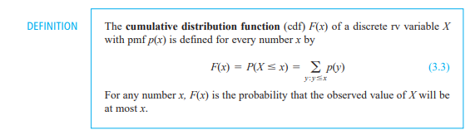

YOU NEED TO HAVE EVERY p(y) up to that spot x, calculated first

**IT’S A BINOMIAL RV IF THE QUESTION IS OF THE FORM “IS, OR ISN’T”:**

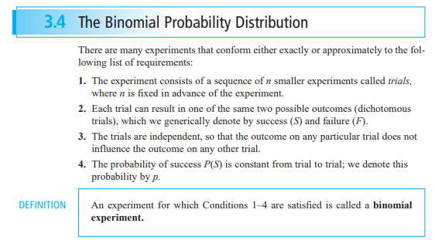

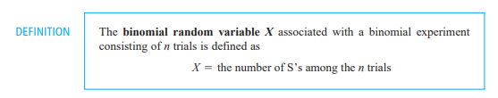

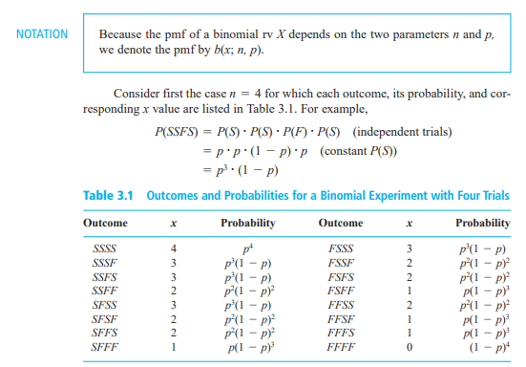

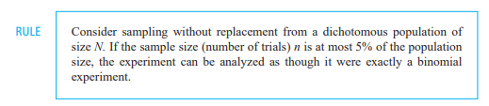

**BINOMIAL FORMULA - prob for x # of discrete S’s in n trials**

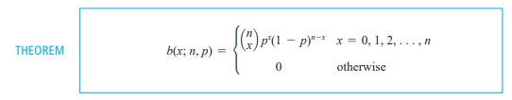

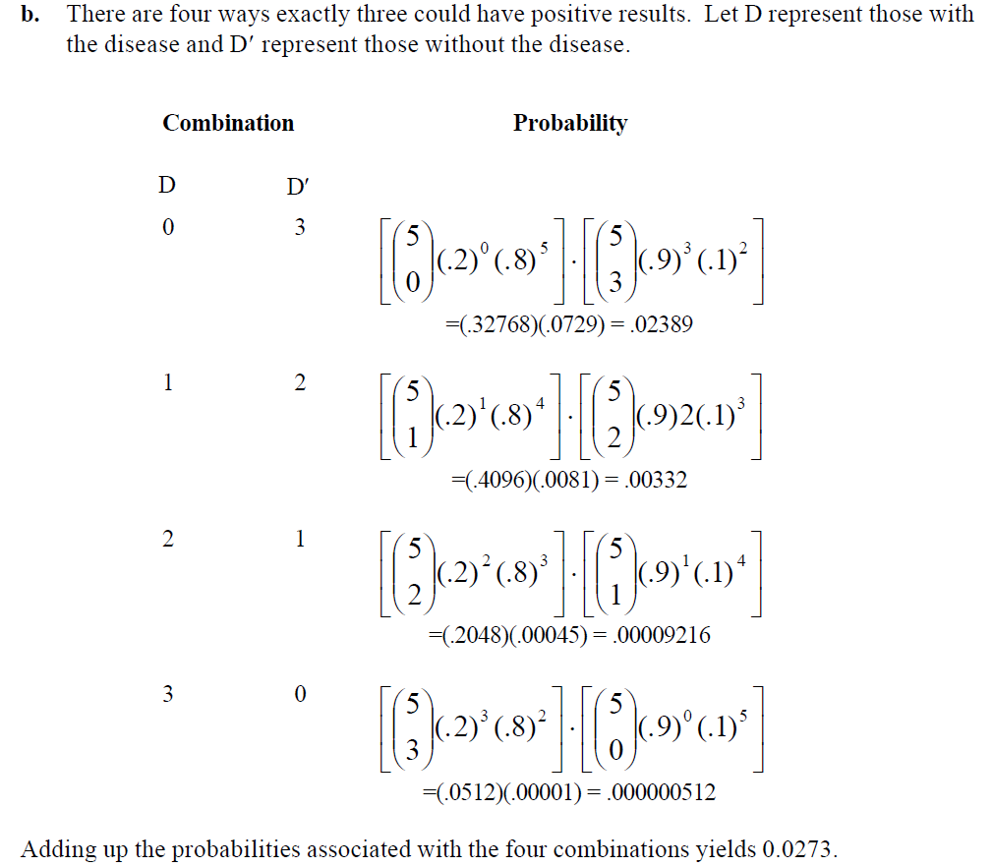

**BINOMIAL CDF sums up the PMF, prob for X is at most some number**

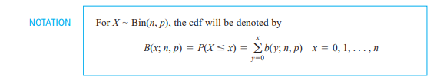



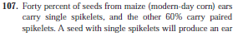 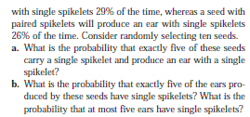

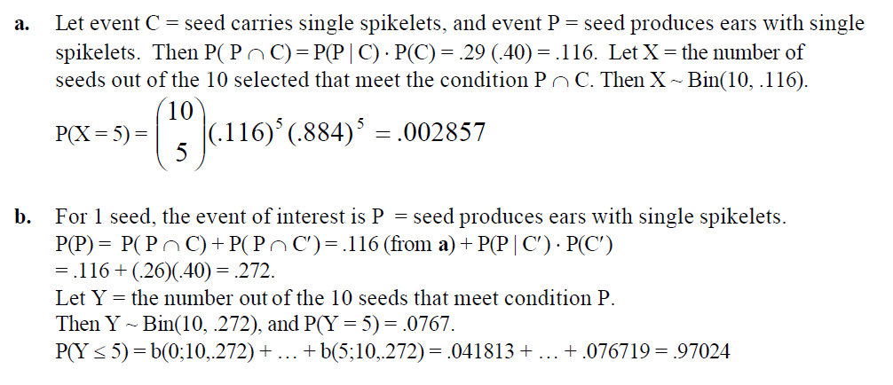

**BINOMIAL MEAN/E(X), VAR, AND STD DEV**

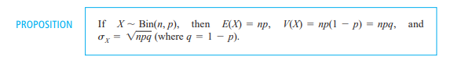

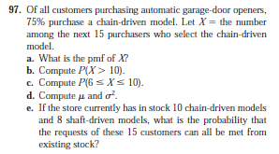

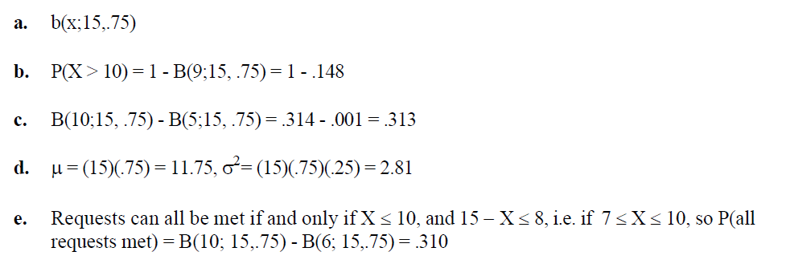

**HYPERGEOMETRIC – the PMF for the # of S’s in a single sample trial**

**NEGATIVE BINOMIAL – fixed # of S’s, probability of # of F’s that come first**

(the number of successes are fixed and the number of trials varies randomly)

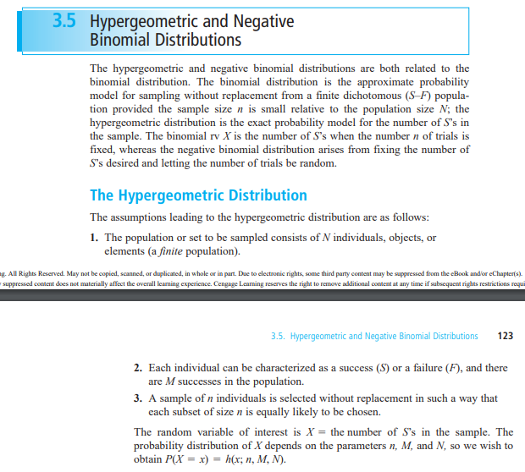

**HYPERGEOMETRIC function for probability of a certain x # of S’s**

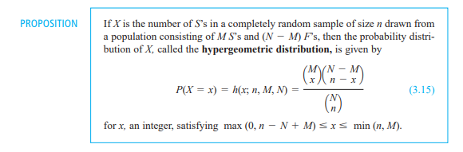

**HYPERGEOMETRIC E(X), VAR**

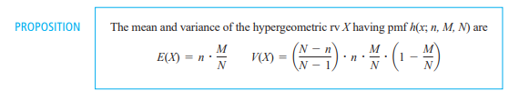

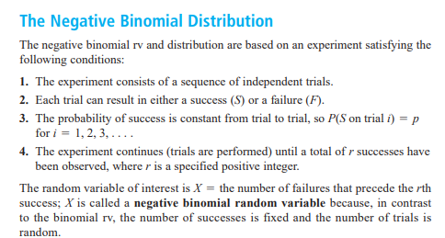

**NEGATIVE BINOMIAL PMF – prob of # of F’s before rth S**

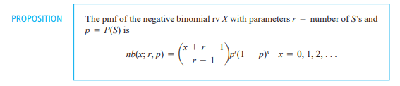

**NEGATIVE BINOMIAL IN TERMS OF Y = TOTAL TRIALS FOR rth S**

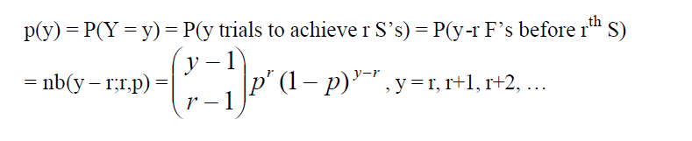

**NEGATIVE BINOMIAL E(X) AND VAR**



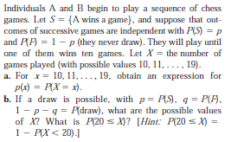

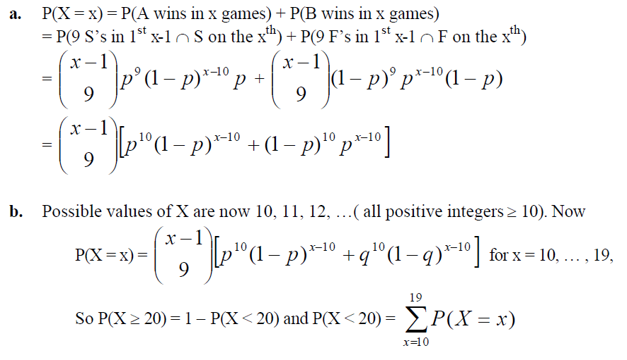

**POISSON**

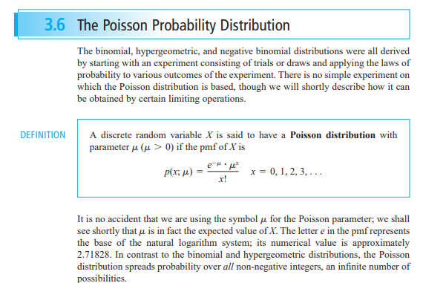

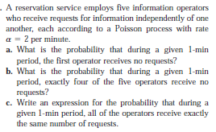 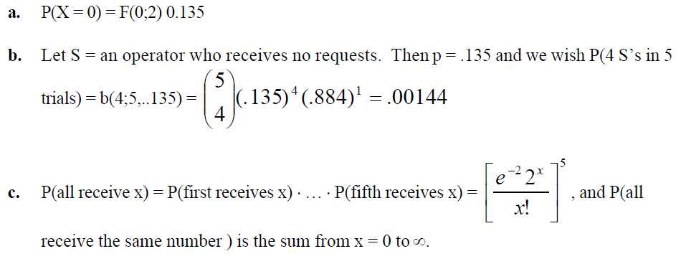

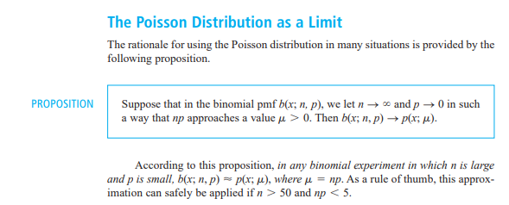

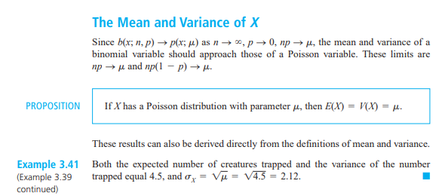

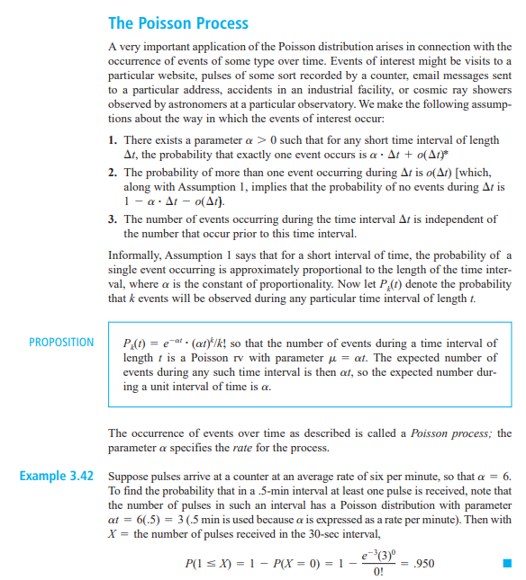

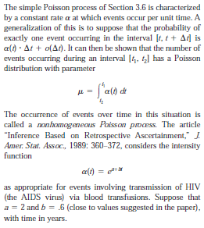 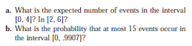

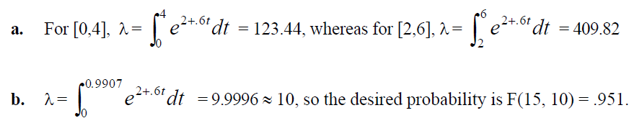



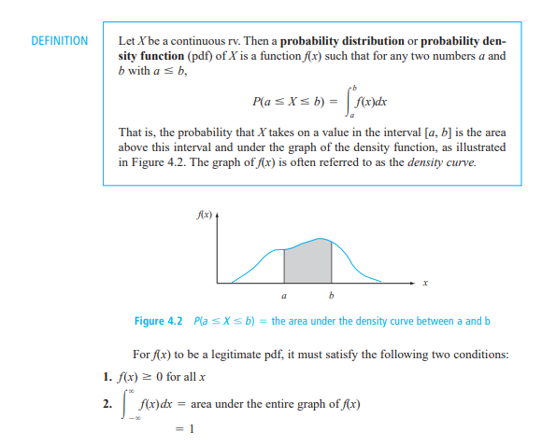

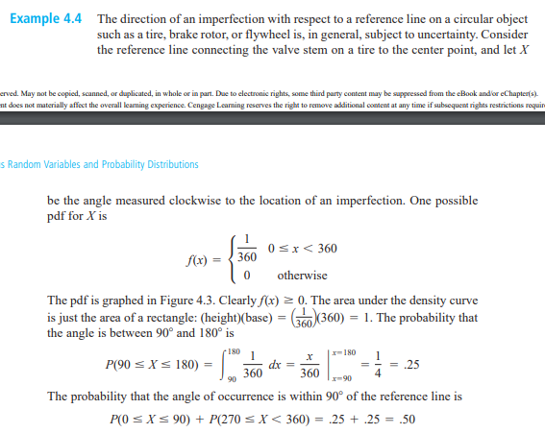

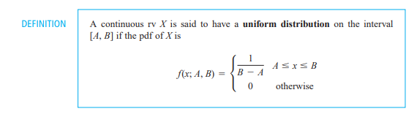

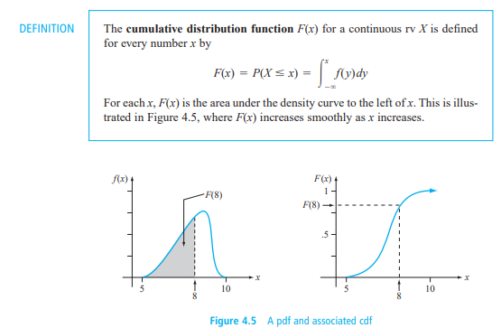

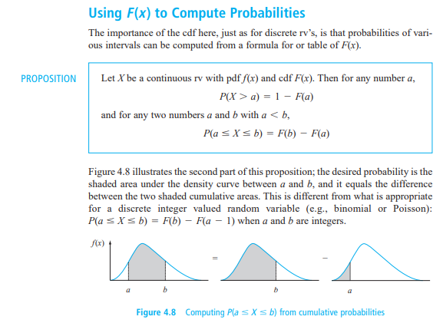

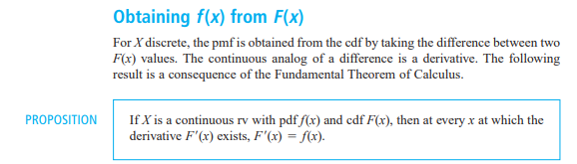

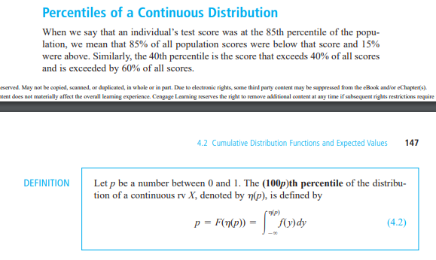

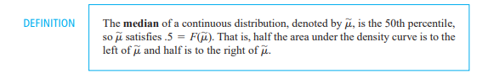

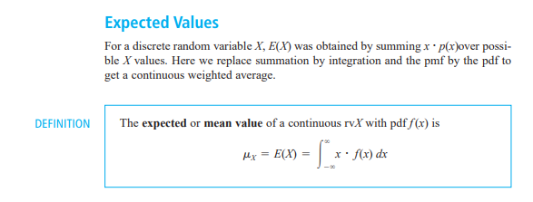

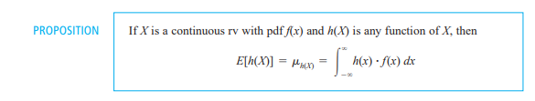

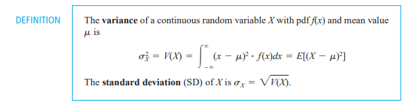



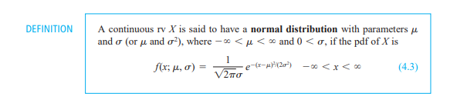

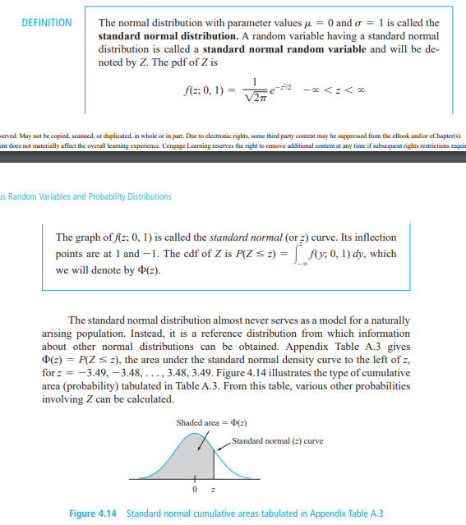

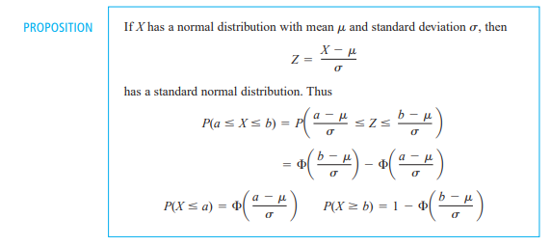

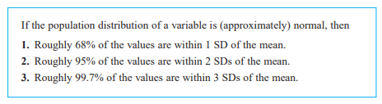

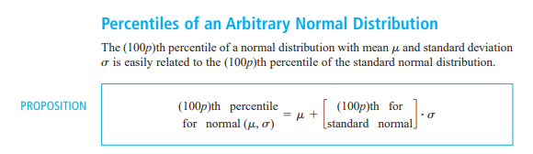

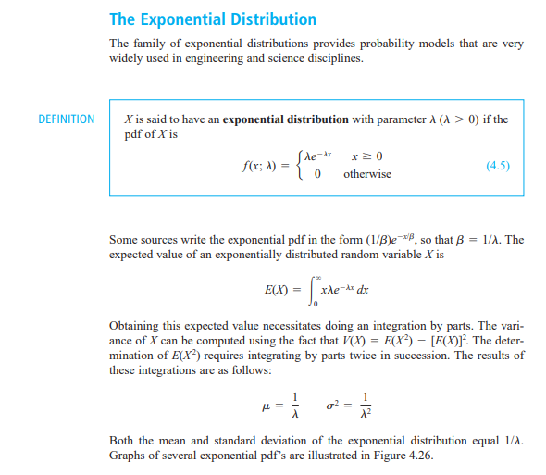

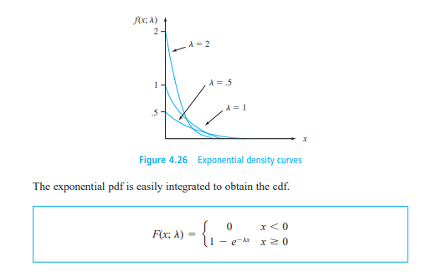

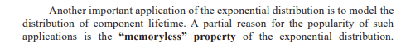

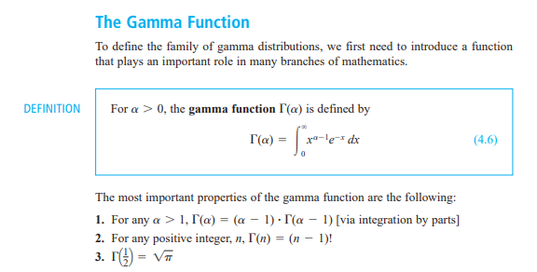

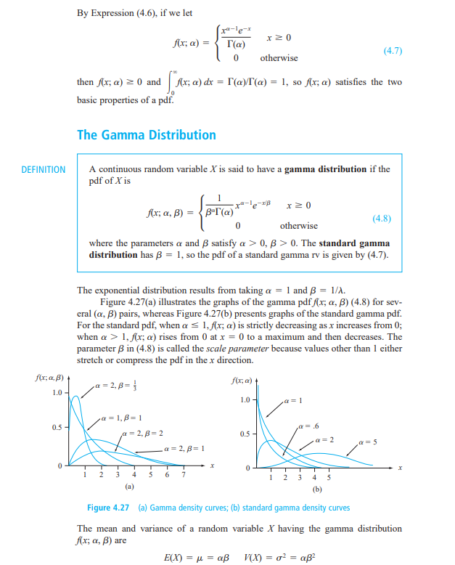

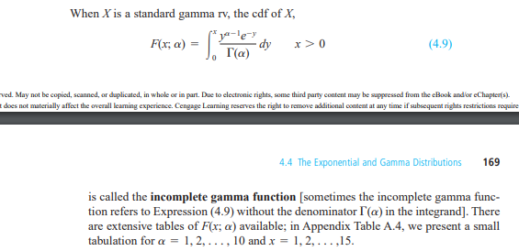

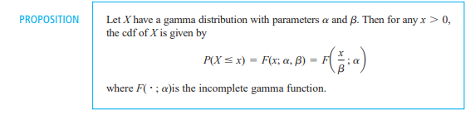

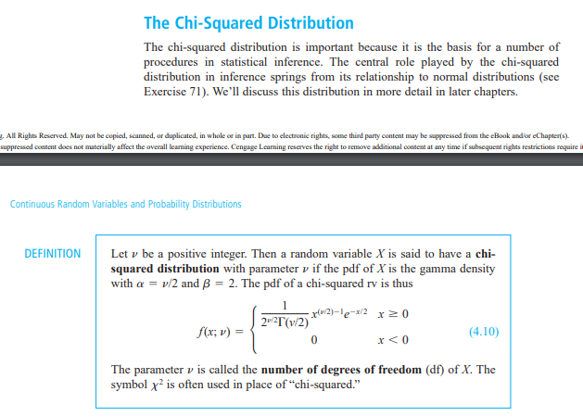

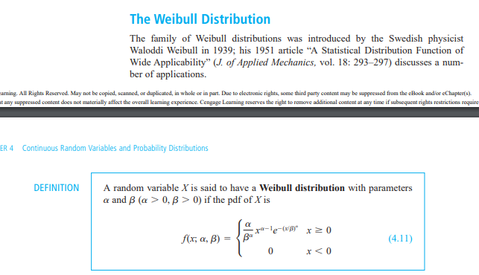

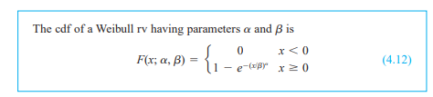

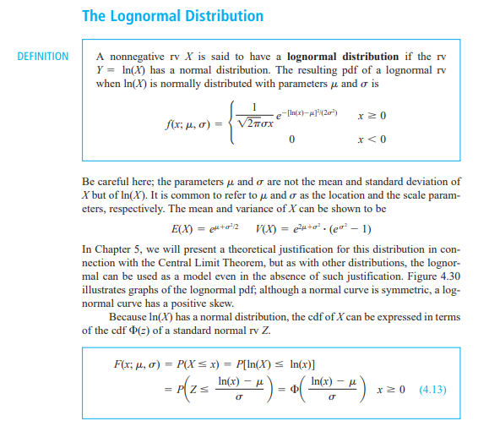

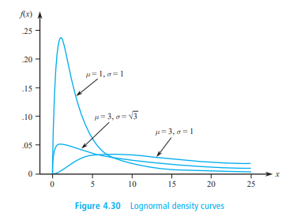

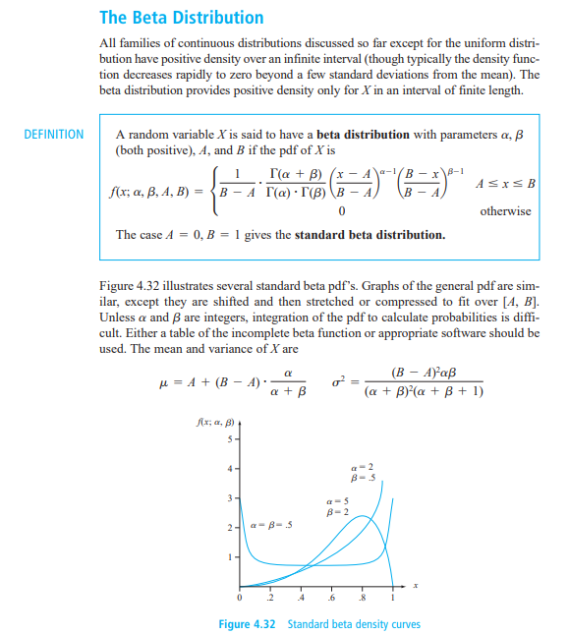



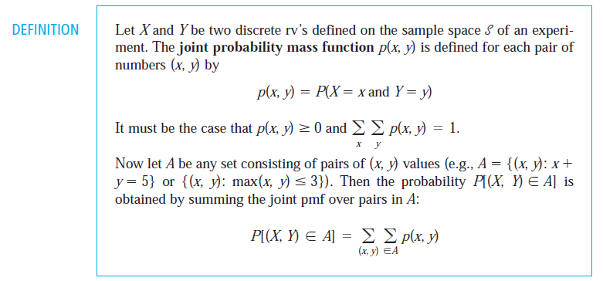

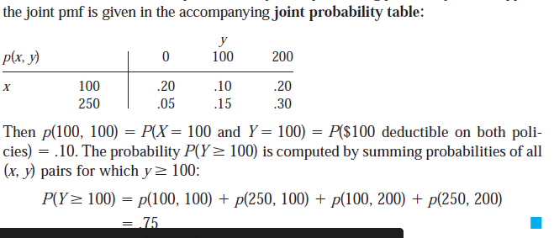

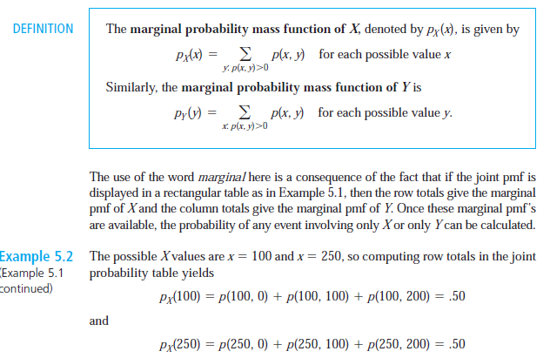

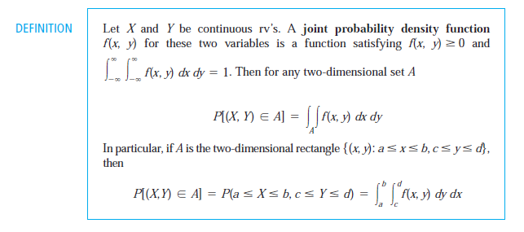

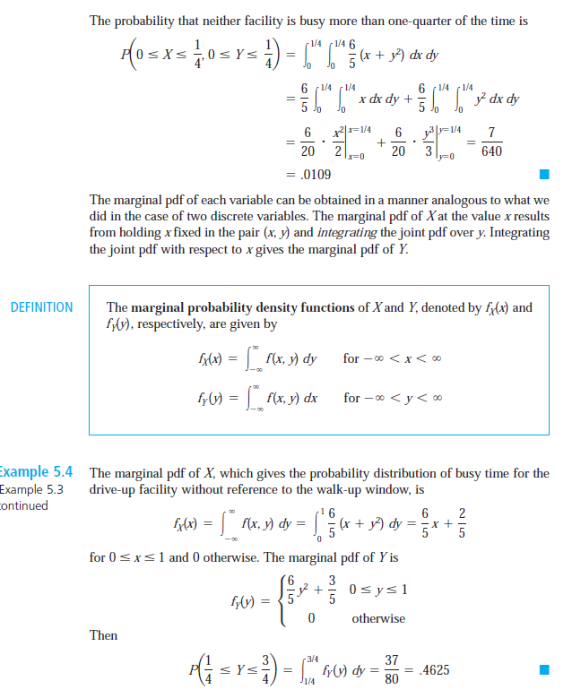

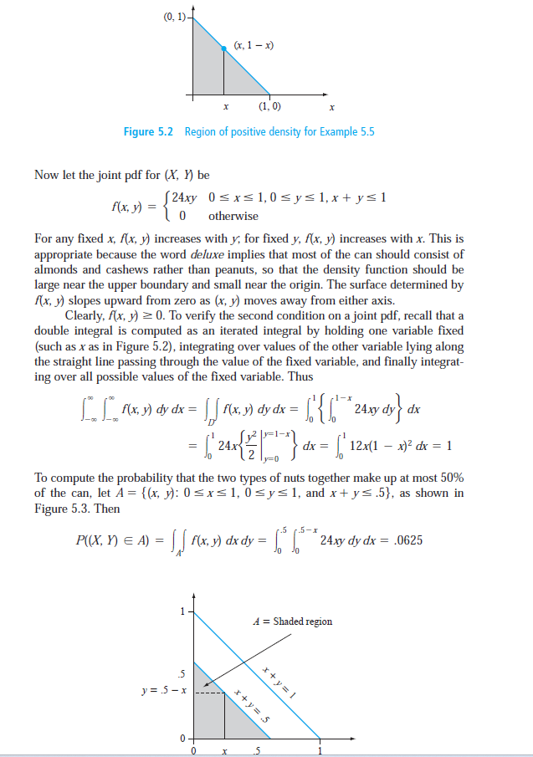

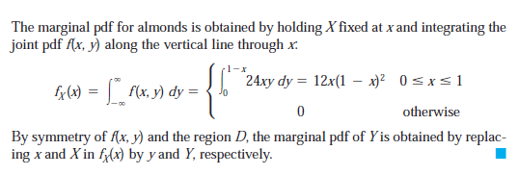

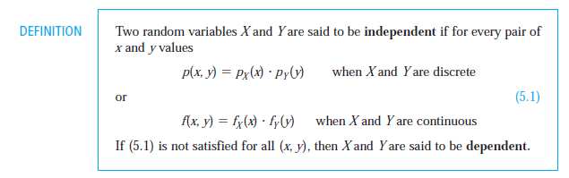

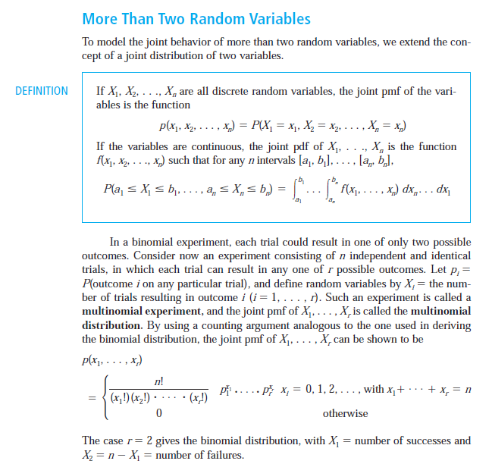

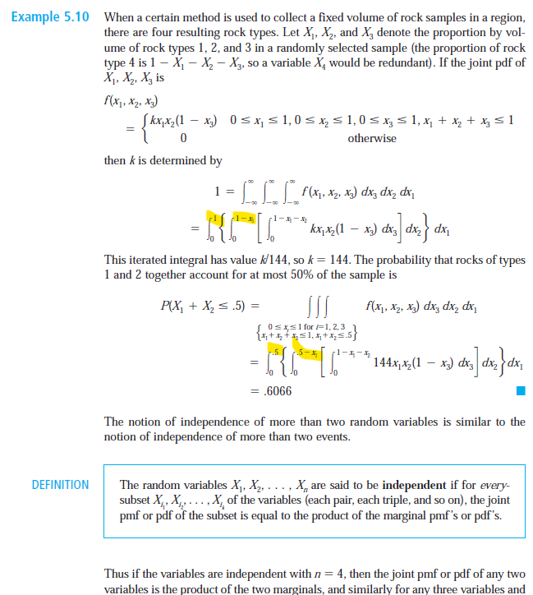

Because the variable is gone…the equation is integrated away in steps

